9 How to Copy and Paste Keyframes in DaVinci Resolve on Fusion Page
~ Part 2~

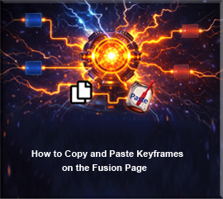
Even though, you may have started out on the Edit page, if you just added text to your project. You will have to move over to the Fusion page, to work with it.
Watch it-Text is one of those got-cha things. If you add a generated background, and then drop text onto it, it will throw you into a fusion clip on your timeline. Once you have been thrown into a fusion clip, you have been fusioned, and the keyframe panel on the edit page, will be locked out to you.

Edit Page
So, let’s start out on the Edit page, in the DaVinci app.

On the Cut page, you can find a tab for Titles, but on the Edit page, you have to go through a few more steps to get to it.
Effects- Titles
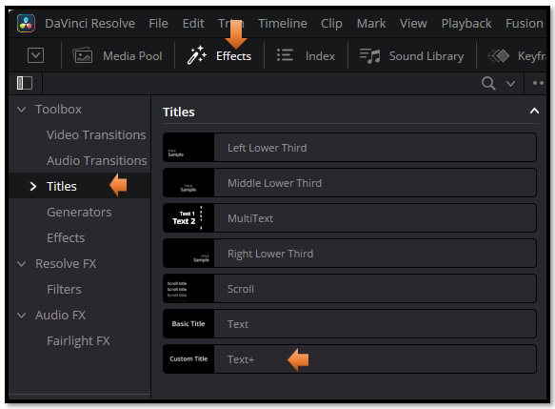
Watch It! this is where things might go a bit haywire. We could have added a movie clip with a background on it, or pulled a image down on the timeline, but we did not. Instead we did this.
Effects-Generator-Background
With a background in there, you can see the clip on the timeline, and you can also see the nodes in the fusion ppanel
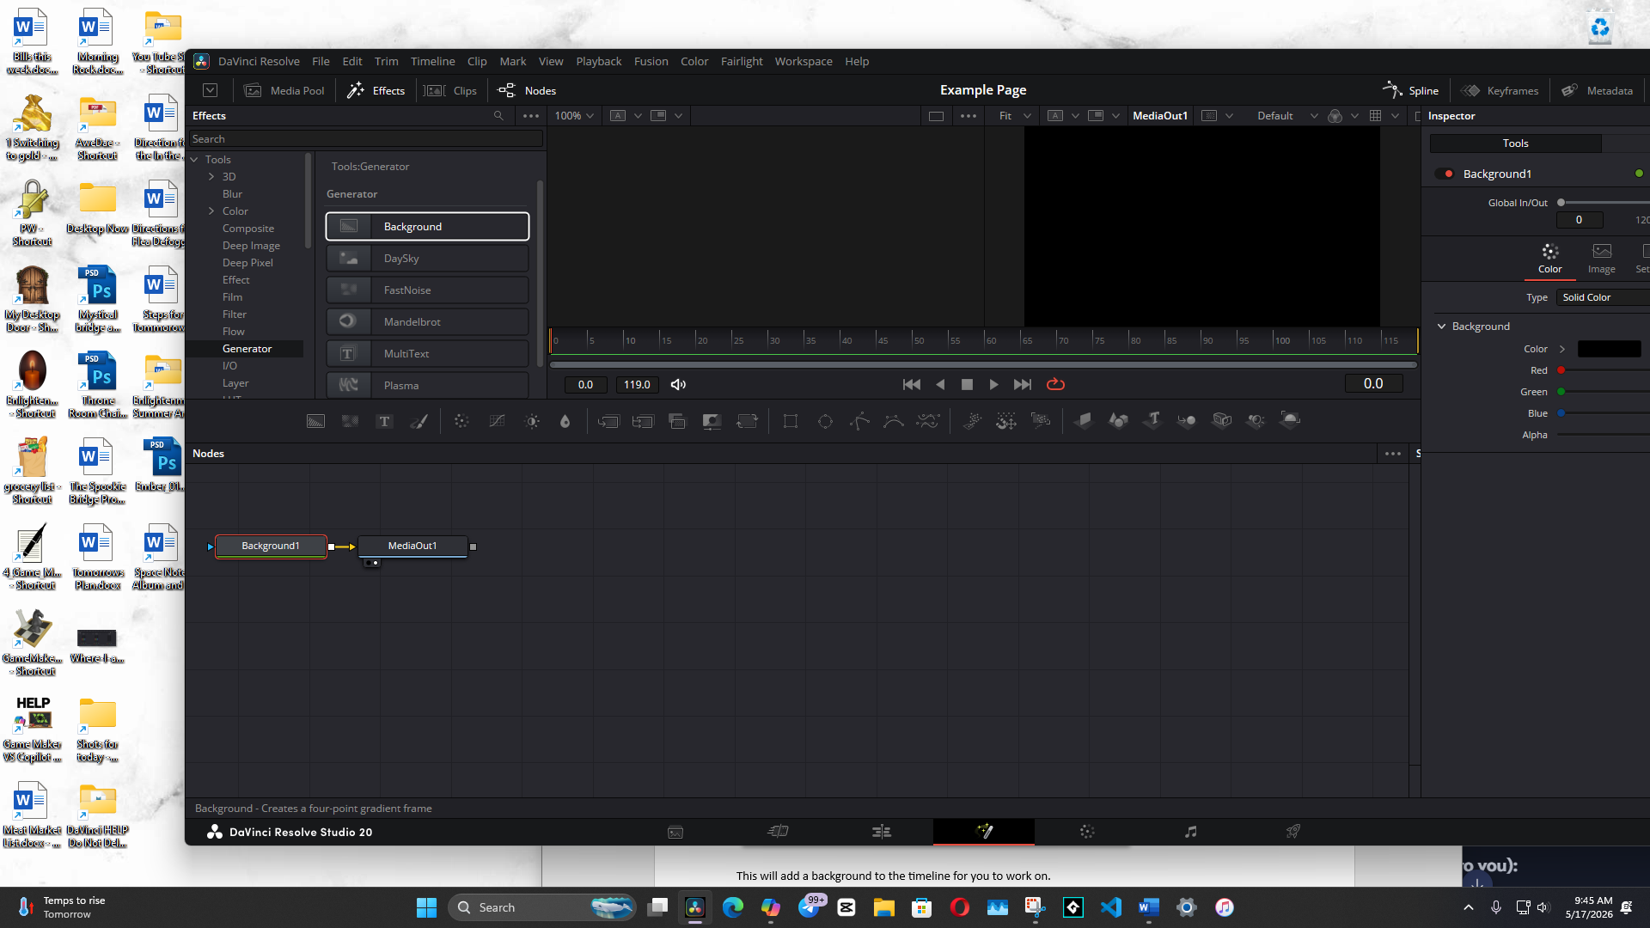
This will add a background to the timeline for you to work on.
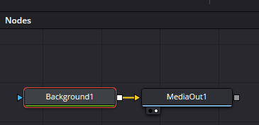
Now you can go back to Titles in the Effect Panel
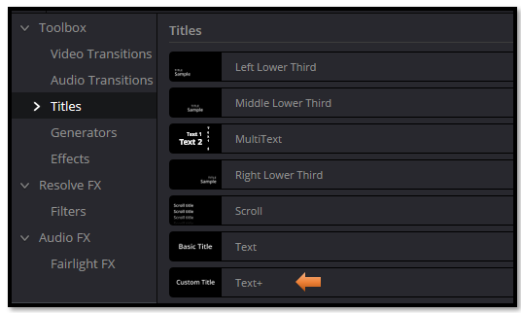
- Add a Text+
Drag and drop the text from the left panel and place it on the center screen
Your background layer on the timeline should look like this
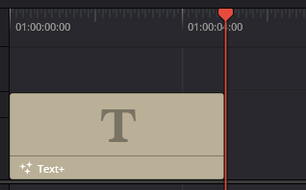
Click on the clip that is on the timeline to bring up your settings in the Inspector.

Animate something using your Inspector

Start out in the text tab and set how you want the text to look. Notice in the text tab, I set a keyframe for color, so it can now change throughout the video. Make sure you set the starting look on frame one, and then you can do what ever you want.

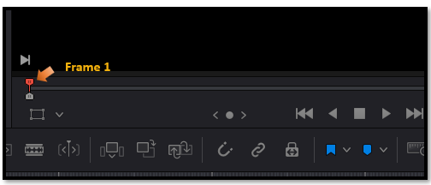
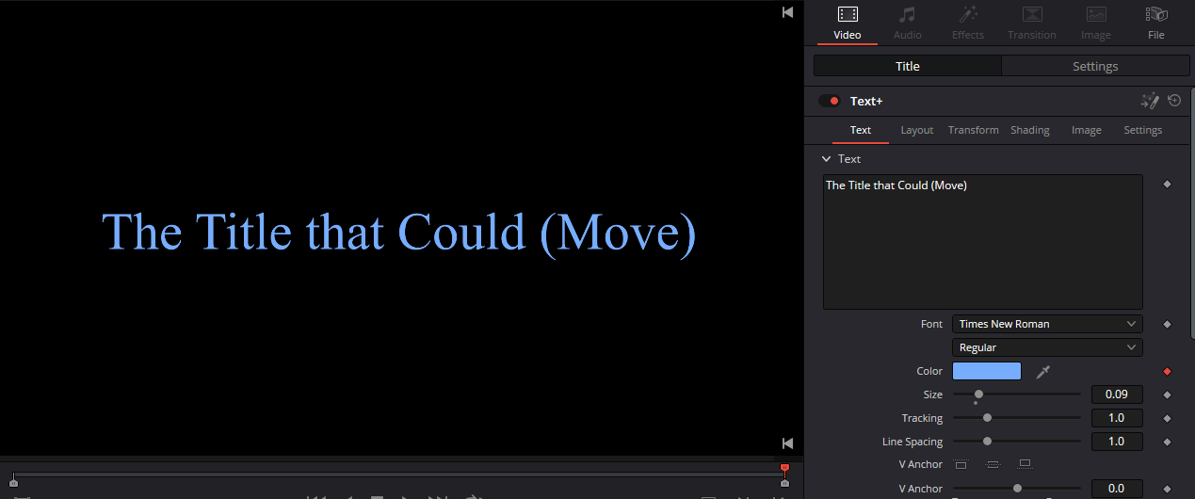
Now in the Inspector move over to the Layout tab, to move the text, we could move it left right top or bottom. I will move it off to the right. Make sure DaVinci knows what you want your starting point to be, so make sure you set a diamond to red on frame one for this too.
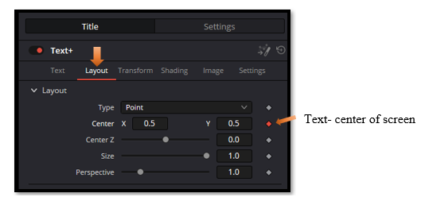

- Click the diamond to set a few keyframes
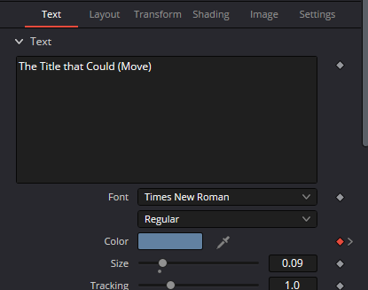

Remember to also set your last frame, so animation knows what it is doing.
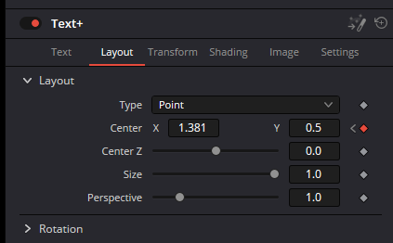

2. Open the Keyframe Panel
This is the part beginners always miss.
- In the Edit page
- Top-right of the timeline
- Click the Keyframe icon (looks like a diamond)
This opens the mini keyframe timeline under your clip.

3. Expand the clip’s keyframes
Click the little arrow next to the clip name so you can see:
- Transform
- Cropping
- Text
- etc.
Then expand the parameter you animated (e.g., Center).
Now you’ll see the diamonds.

4. Select the keyframes you want to copy
You can:
- Click a single diamond
- Or drag-select across multiple diamonds
- Or Shift-click to select specific ones
They will highlight when selected.

5. Press Ctrl+C
This copies the selected keyframes.

6. Move the playhead to the new location
This is important:
The Edit page pastes keyframes starting at the playhead, not relative to the original timing.
So if your original animation was 12 frames long, the pasted version will also be 12 frames long, starting wherever your playhead is.

7. Press Ctrl+V
Boom — the keyframes appear at the new location.
You can now:
- Slide them
- Delete them
- Add more
- Or copy/paste again

